

COMPUTER GRAPHICS BIT BANK
1. The surfaces generated by cubic polynomials in both u and v parameters are called as
a. Quadric
b. Bi-Quadric
c. Cubic
d. Bi-cubic
2. Which of the following is not one of the polygon - mesh representation
a. Explicit representation
b. Pointers to a vertex list
c. Pointers to an edge list
d. Pointers to a polygon list
3. If
a.
b.
c.
d.
4. Howmany polynomials in a parameter 't' are to be defined for identifying a point on a 3-D curve
a. One
b. Two
c. Three
d. Number depends on complexity
5. The surfaces which are defined implicitly by an equation are called as
a. Cubic surface
b. bi-cubic surface
c. Quadric surfaces
d. Binomial surfaces
6. Which of
a.
b.
c.
d.
7. Which of
a.
b.
c.
d.
the following is not a common representation of 3D surface
Polygan mesh surface
Parameteric surface
Quadric surface
Neural surface
the following is not a characterstic of parametric curves
Simple
Possible to generalize
Possible to identify any number of intermediate points
Huge data base of intermediate points need to be explicitly stored
are points on a plane, then the plane's normal is computed as
8. A set of connected polygonally bounded planar surfaces is called
as a. Polygan mesh
b. Solid object
c. 3-D object
d. mesh-cube
9. A polynomial curve using a parameter t is called
as a. Parametric polynomial curve
b. Cubic polynomial curve
c. Quatric polynomical curve
d. Solid polynomial curve
10. The polynomial with maximum power 3, is called as
a. Cubic polynomial
b. Quadric polynomial
c. Binomial polynomial
d. Acute polynomial
11. Which of
a.
b.
c.
d.
12. Which of
continuty)
a.
b.
c.
d.
the following is not a reason for using cubic polynomials in parametric form
It gives sufficient flexibility
does not introduce unwanted wiggles
Polyonomials of degree 4 and above involve more computations
It is not possible to generate curves and surfaces with other kinds of polynomials
the following is true about G1 (Geometric continuty) and C1 (Parametric first degree
C1
G1
C1
G1
continuty implies G1
continuty is generally more restrictive than is C1
and G 1 are identical
continuity imples C1


13. Which of
a.
b.
c.
d.
the following parametric curves are lowest-degree non-planar curves in 3D
Cubic
Quadratic
Curves with degree 4
Curves with degree n
14. If the directions of two segments' tangent vectors are equal at a joining point, the curve is said to have _ _ _ _ _ _
_ _ _ geometric continuety
a. G 0
b. G1
c. G 2
d. G n
15. In the case of curve joining, G1 geometriccontinuty means
a. Only geometric points are same
b. The geometic slopes of the segments are same
c. The geometric slopes and lengths of the segments are same
d. The geometric slopes are different but the lengths of the segments are same
16. If the direction and magnitude of
is called _ _ _ _ _ _ _ _ continuous
a. C0
b. C1
c. C2
d. Cn
17. For two curves to join smoothly, the essential requirement is
a. Their tangent - vector directions must match
b. Their magnitudes must match
c. Both their tangent vector directions and magnitudes must match
d. either tangent vector directions or magnitudes must match
18. Howmany coefficients are there in a cubic polynomial
a. 3
b. 4
c. any number
d. 1
19. To deal with finite segments of the curve, without loss of generality, we resptrict the parameter t, to _ _ _ _ _ _
interval
a.
b.
c.
d.
20. If Q(t) is a cubic polynomial, then the tangent vector of the curve is
a. [Q(t)]2
b. Q'(t)
c. 1/Q(t)
d.
21. The basis matrix for Hermites curve is
a.
through the
derivative are equal at the joining point, the curve
b.
c.
d.



22. The property that the curves can be transformed by transforming the geometric vectors and then using it
to generate the transformed curve makes the Hermites curves
a. Invariant under only rotation
b. Invariant under only scaling
c. Invariant under only translation
d. Invariant under rotation, scaling and translation
23. Out of the four blending functions of Hermites, howmany are non-zero at t=0
a. 1
b. 2
c. 3
d. 4
24. For two Hermite cubics to share a common end point with G1 geometrical continuty, which of the
following conditions must be satisfied
a. The magnutudes of the vectors must be same
b. The tangents at the end points must be same
c. Both the magnutuedes and tangents must be same
d. Both must haveorder continuty
25. The Horner's rule for factoring polynomial f(t) =
a.
b.
c.
d.
26. The Hermite curves are not invariant under
a. rotation
b. scaling
c. translation
d. perspective projection
27. Which of
a.
b.
c.
d.
the following require, for its definition, two end-points and two end-point tangent vectors
Hermite curve
Bezier curve
B-spline
β -spline
is
28. If M is a basis matrix and G is a matrix representing a vector of geometric constraints, then the Hermite's
coefficent vector matrixis defined as
a. C=M.G
b. C=M+G
c. C=M
d. C=M-G
29. The Hermite form of the cubic polynomial curve segment is determined by
a. Any four control points
b. Either four control points or four tangents
c. Two end-points and the tangents at two end-points
d. Two end-points and any other two intermediate points
30. The cubic curves are _ _ _ _ _ _ _ _ _ combinations of the four elements of the geometry
vectors a. linear
b. non-linear
c. complex
d. higher -degree
31. The Bazier basis matrix M B is defined as
a.
b.
c.

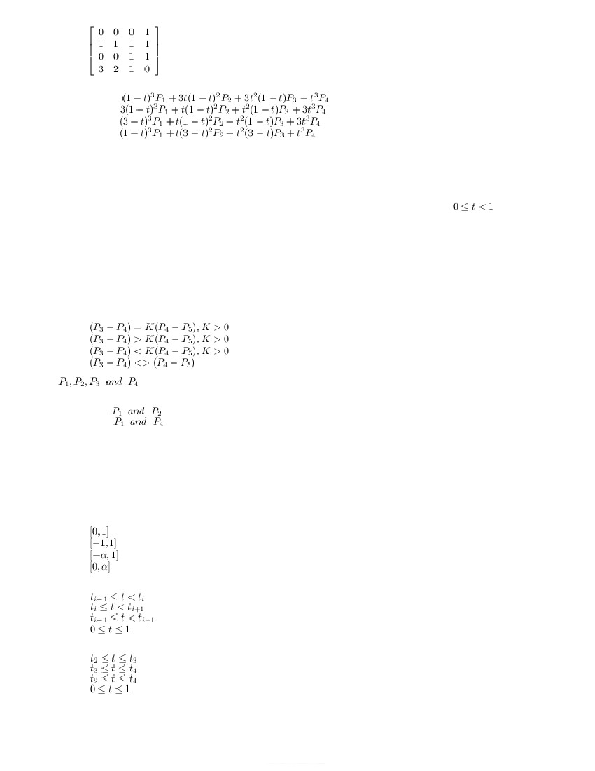

d.
32. The general equation for Bernestein polynomials is given by
a. Q(t) =
b. Q(t) =
c. Q(t) =
d. Q(t) =
33. Which of
a.
b.
c.
d.
the following is false about Bazier curve
The blending functions are non negative
The blending function are sum to one
The output curve is completely within the convex hull
At t=0, all the Bernstein polynamials are zero
34. In the Bazier curve, the sum of all Bernstein polynomials at every point in the range of
is a. Unity
b. Zero
c. n units if there n control points
d. varies with position of control points
35. If the given four control points of Bazier curve forms a convex hull, the corresponding output curve
is a. completely inside the convex hull
b. completely outside the convex hull
c. oscillates between outside and inside
d. not a function of control points
36. At the joining of two Bezier curves, G1 continuty is provided only
if a.
b.
c.
d.
37. Ifare four control points, in the same order, given as input for Bazier curve, then the
curve passes trough
a. all four control points
b. Only
c. Only
d. The control points influence, but curve does not pass through any control
point
38. The property that the change of location of any control point will have influence on every point on the curve
or surface is called as
a. Global control
b. Local control
c. Generic control
d. enfluence control
39. The range of parametric variable 't' used in Bazier curve
is a.
b.
c.
d.
40. In uniform nonrational B-splines, the curve segment Q 1 is defined in the parameter range of
a.
b.
c.
d.
41. In Uniform non-rational B-splines, the curve segment Q 3 is defined in the parameter range of
a.
b.
c.
d.
42. If the B-spline curve is defined with m+1 control points, total number of curve segments in the B-spline curve is
a. m-2
b. m+1
c. m



d. 1
43. Which of
a.
b.
c.
d.
the following is not a feature of local control
moving a control point effects only a part of a curve
time needed to compute the coefficients is greatly reduced
all cubic splines are chatacterised by local control
knot values are defined in algorithms
44. In uniform B-splines, the term uniform means
a. Knots are spaced at equal intervals
b. Knots are spaced at two end points of the curve
c. Knots are spaced at regular intervals
d. knots are spaced at steep curvatures
45. Which of
a.
b.
c.
d.
the the following is not a characterstic of B-spline blending functions
Everywhere non negative
Sum to Unity
The output curve is constraned to a convex hull
Blending function is influenced by all m+1 control points
46. B-Splines consist of curve segments whose polynomial coefficents depend on just few control points. This property
of B-Splines is called as
a. global control
b. local control
c. generic control
d. infinite control
47. If the parametric functions x(t),y(t) and z(t) each are defined as the ratio of two cubic polynomials, such
splines are called as
a. rational
b. semi rational
c. non-rational
d. trivial
48. In the B-splines algorithm, the term B stands for
a. basic
b. basis
c. base line
d. bicubic
49. According to phase specular - reflection model, as the specular parameter 'n' s increases, the sharpness of
specular reflection
a. increases
b. decreases
c. remain unchange
d. increase until n=256 and then decreases
50. The range of values for the reflection coeffients followed in illumination model is
a. 1 to 2
b. 0 to 1
c. -1 to 1
d. 0 to α
51. The amount of incident light specularly reflected is depending on angle between
a. incident light ray and the surface normal
b. reflected light ray and the surface normal
c. reflected light ray and the direction of view point
d. incident light ray and the direction of view point
52. At the sharp specular high-lights in Phong illumination model, what are the corresponding K s and n values where
K s is specular reflection coefficent and 'n' is an integer constant used in
a. Both K s and n are large values
b. K s is large and n is small value
c. K s is small and n is large value
d. both K s and n are small values
53. The light which is from a non-directional source of light, the product of multiple reflections from many sources of
light is called as
a. ambient light
b. self-luminous light
c. specular light
d. diffuse light
54. If the Ip is the point light source intensity, then the diffuse illumination equation is given
by a. I =

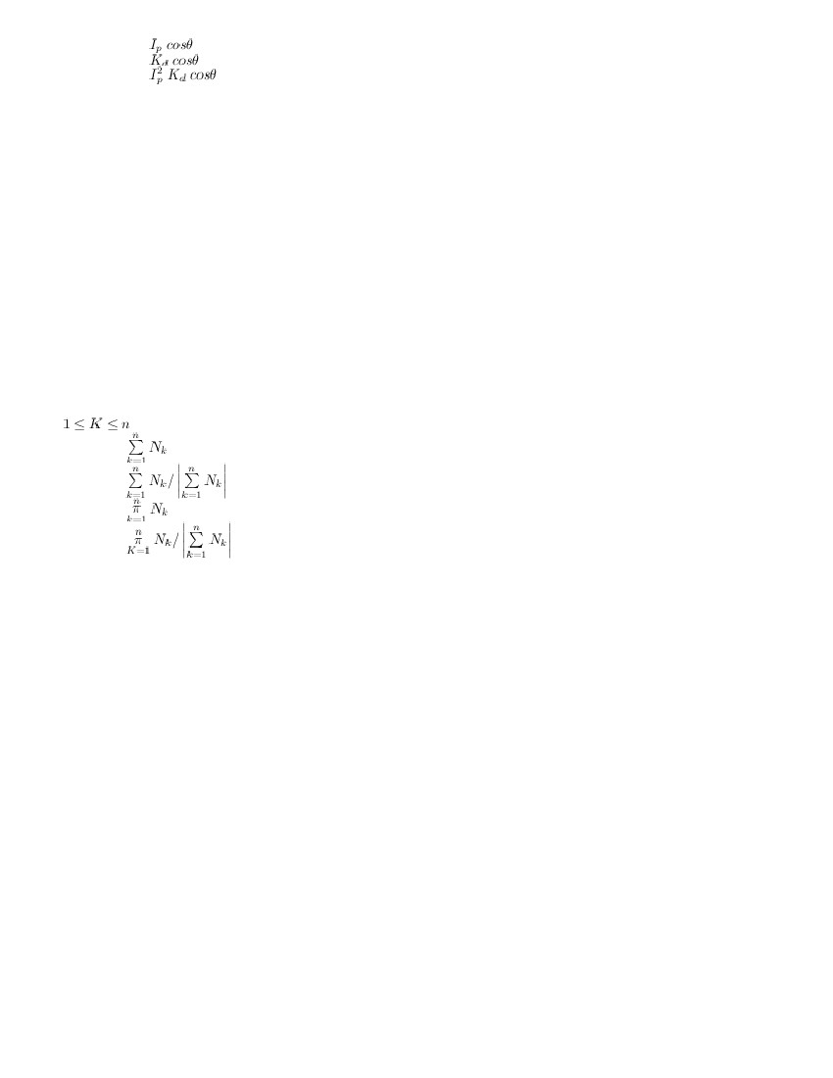

b. I =
c. I =
d. I =
55. Specular
a.
b.
c.
d.
56. Surfaces
a.
b.
c.
d.
reflections are observed on
completely transperent objects
shiny surface objects
rough surface objects
course objects
that are rough and grainy, tend to scatter the reflected light in all directions. This scattered light is called
Specular reflection
Diffuse reflection
Ambient reflection
Shiny reflection
57. Surfaces that are shiny and the light sources create highlights or bright spots
called a. specular reflection
b. distributed reflection
c. diffuse reflection
d. ambient reflection
58. To compute the final intensity at any arbitrary surface point, atmost howmany interpolations are to be performed
a. 1
b. 2
c. 3
d. 4
59. If the vertex V is surrounded by 'n' polygons and the surface normal of each of the surrounded polygon is N k
, then the unit vertex normal N v at V is given by
a.
b.
c.
d.
60. Incremental calculations are used to obtain intensity values between scan lines and along scan lines. Reason
for following this approach is
a. It gives smooth intensities
b. It gives pleasant intensities
c. to make it frce mach-band effect
d. to make it computationally efficient
61. The principle of Gouraud shading is
a. vector interpolation
b. intensity interpolation
c. surface interpolation
d. one intensity for one surface
62. The principle of constant intensity shading is
a. vector interpolation
b. interisity interpolation
c. single intensity for complete polygon
d. surface interpolation
63. Which of
a.
b.
c.
d.
the following draw back is observed in Gouraud shading
Mach bands
intensity discontinuities at the surface boarders
Computationally very expensive
incremental calculations are not applicable
64. In Gourand shading, the Mach band effect is reduced or eliminated
by a. dividing the surface into a greater number of polygon
faces b. Using encremental calculations
c. entersity inter polations
d. computing the entensities along the scan lives
65. In
1)
2)
3)
which of the following algorithms, these steps are followed in the same sequance:
determine average unit normal vector at each vertex
linearly interpolate the vertex normal and
apply illumination model for the surface points

a.
b.
c.
d.
Phong
Gouraud
Constant intersity shading
ray-tracing
66. Which of the following shading algorithms linearly interpolate the vertex normals over the surface of the
polygon, before applying the illumination model.
a. Phang shading
b. Gouraud shading
c. constant - intensity shading
d. ray - tracing
67. The limitation of phong-shading algorthm is
a. It require more calculations
b. It causes mach-band effects
c. There are sharp change in shade values at the boarders
d. Encremental calculations are not applicable
68. The highlights in the polygon interiors caused by specular -reflection illumination model are clearly visible in
a. Gourand shading
b. Phong shading
c. Constant shading
d. Flat shading
69. The three-dimensional matrix transformation for translation with a units along x-axis and b units along y-axis and
c units along z-axis is
a.
b.
c.
d.
70. In 3-D scaling transformation, the scalling factors s x ,s y and s z are
a. linearly dependent an each other
b. non-linearly dependent an each other
c. independent
d. independent only in case magnification
71. The three-dimensional matrix transformation for scaling with a units along x-axis and b units along y-axis and c
units along z-axis is
a.
b.
c.
d.

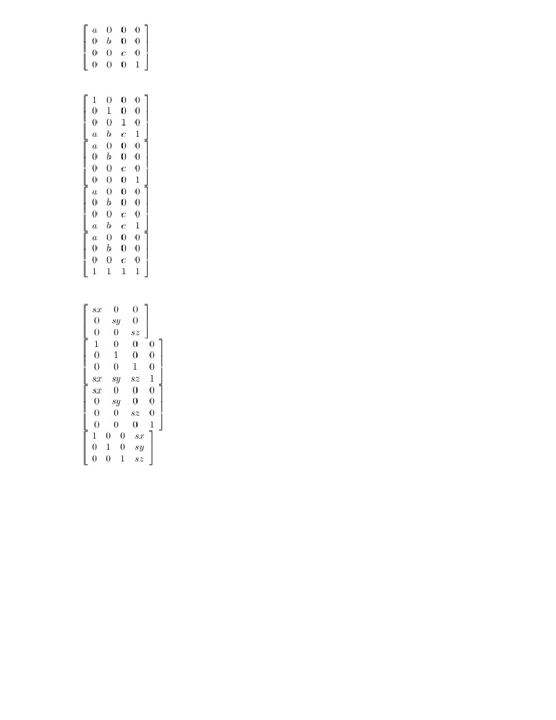

72. The direction and displacement of the translation is precribed by a vector V=aI+bJ+cK. The required trasnlation
matrix given by
a.
b.
c.
d.
73. If s x ,s y and s z are the sxaling factirs in x,y and z directions, then the required scaling transformation matrix
in homogenous coordinate system is given by
a.
b.
c.
d.
74. A transformation system in which an object in created and described in coordinates with respect to its own
and indipendent object coordinated space, and place an instance or copy of it within a larger scence, is called
as
a. geometric transformation
b. coordinate transformation
c. instance transformation
d. complex transformation
75. If the axis of
is a. y
b. z to
c. x to
d. y to
rotation is X, then the direction of positive rotation
to z
x
y
x
76. If the axis of rotation is Y, then the directionof positive rotation is
a. y to z
b. z to x
c. x to y
d. y to x
77. In 3-D space rotation of an object is done about
a. a point
b. an axis
c. a plane
d. a hyper plane
www.UandiStar.org

78. In 3-D space, the scaling is performed with respect to
a. a reference point
b. a reference plane
c. a reference axis
d. an hyper plane
79. In 3-D transformations, the two scalling operations are
a. alwalys commutative
b. always non- commutative
c. commutative only if all scalling parameters of atleast one of the two scaling matrices are same.
d. commutative only if all the scalling parameter of both the scalling matrices are same
80. In a 3-D
a.
b.
c.
d.
scaling transformation, all the three scalling parameters
must be positive and greater than one
must be positive
either positive or negative
must be a combination of positive and negative
81. let v is a vertex of an object p. When the scaling operation is applied on the object p with respect to vertex
v, which of the following is true
a. The cordinates of only vertex v are unchanged
b. The coordinates of all vertices are unchanged
c. The coordinates of vertices are changed in magnification
d. The coordinates of vertex v are unchanged only if all the scaling factors are same
82. If the axis
a. y
b. z
c. x
d. y
of rotation is Z, then the directionof positive rotation is
to z
to x
to y
to x
83. The three minesional matrix transformation for rotation with an angle θ with respect to z-axis in the negative
direction is
a.
b.
c.
d.
84. The three dimensional matrix transformation for rotation with an angle θ with respect to y-axis is the negative
direction is
a.
b.
c.

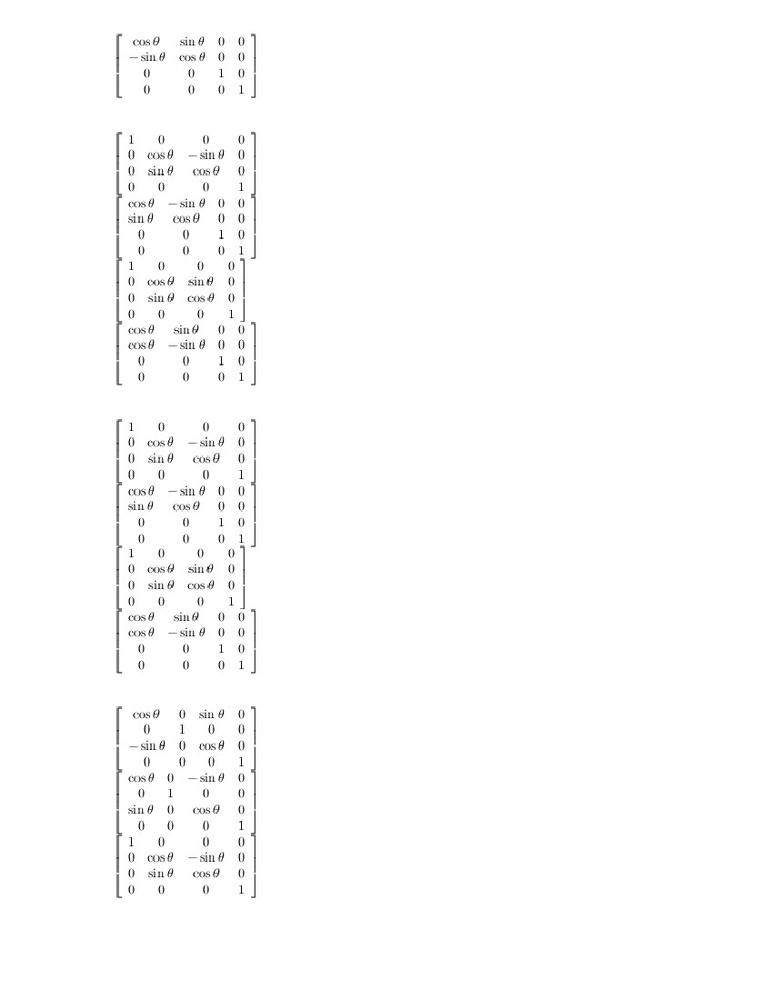

85. The three dimensional matrix transformation for rotation with an angle θ with respect to x-axis in the positive
direction is
a.
b.
c.
d.
86. The three dimenesional matrix transformation for rotation with an angle θ with respect to z-axis in the positive
direction is
a.
b.
c.
d.
87. The three dimensional matrix transformation for rotation with an angle θ with respect to y-axis in the positive
direction is
a.
b.
c.

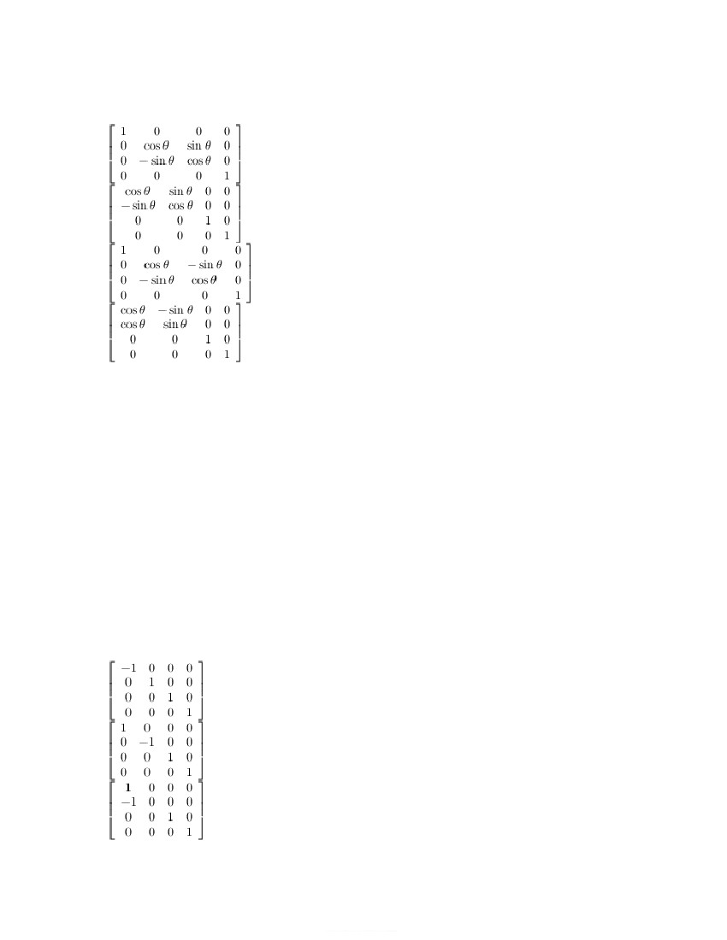

88. The three dimensional matrix transformation for rotation with an angle θ with respect to x-axis in the negative
direction is
a.
b.
c.
d.
89. When looking towards the origin from a positive co ordinate position on each axis, which is the positive
rotation direction
a. clock-wise
b. counter clock-wise
c. up side down
d. upward
90. The x-shear maintains the coordinates of which of the following directions constant
a. x
b. y
c. z
d. y and z
91. The y-shear maintains the coordinates of which of the following directions constant
a. y
b. x and z
c. x,y and z
d. only z
92. The z-shear maintains the coordinates of which of the following directions constant
a. z
b. y and z
c. only y
d. x and y
93. The three-dimensional matrix transformation for reflection of a point with respect to xy-plane
a.
b.
c.

94. Two sucessive reflections about an axis
a. non-commutative
b. do not change the original object position
c. reflects the object to neigbhour quadrant
d. reflects the object to diogonally opposite quadrant
95. In 3-D space the reflections are performed about
a. a point
b. an axis
c. a plane
d. an hyper plane
96. If a given object is reflected about xy plane, the co -ordinates of which axis donot change.
a. x
b. y
c. z
d. x and y
97. If a given object is reflected about xy, plane the co -ordinates of which axis do change
a. x
b. y
c. z
d. x and y
98. Let A V and A N are the transformations for aligning the vectors V and N with vector K, passing through z-
axis, respectively. Then the transformation which aligns the vector V with the vector N is
a.
b.
c.
d.
99. Three-dimensional matrix transformation for reflection of a point with respect to yz-plane
a.
b.
c.
d.
100. Three-dimensional matrix transformation for reflection of a point with respect to zx-plane
a.
b.
c.



d.
101. Basic transformation matrices for rotation, scaling and mirror reflection are defined to apply about _ _ _ _ _ _ _ _
_ , _ _ _ _ _ _ _ _ _ _ _ and _ _ _ _ _ _ _ _ _
a. axis, origin, plane
b. axis, axis, plane
c. plane, origin, plane
d. axis, origin, axis
102. To align an arbitrary vector with any one of the three principal axis, howmany basic rotations are to be performed
a. 3
b. 2
c. 1
d. 4
103. To make an arbitrary plane to be aligned with xy plane, the normal of the plane is to be aligned
with a. z-axis
b. x-axis
c. y-axis
d. both x and y axis
104. Which of
a.
b.
c.
d.
the following transformation, indirectly depends on Rotation operation
shear
scaling
translation
reflection
105. Concatenation of howmany basic transformation matrices is required to align an arbitrary vector with another
vector is 3-D space, if both vectors pass through origin
a. 5
b. 2
c. 1
d. 7
106. Concatenation of howmany basic transformation matrices is required to align an arbitrary vector with another
vector is 3-D space, if both vectors not pass through origin
a. 5
b. 2
c. 1
d. 7
107. To rotate an object about an arbitrary axis the following operations are required What is their correct sequence
i) Applying actual rotation
ii) Rotate the arbitrary vector such that it aligns with one of the principal axis
iii) Rotate the vector which is aligned with one of the principal axis to its original position
a. i),ii) and iii)
b. ii),i) and iii)
c. ii), iii) and i)
d. iii), i) and ii)
108. In a 3-D viewing pipeline following stage are needed. What is the correct sequence of these stages or subtasks
i) Modelling transformation
ii) Projection transformation
iii) Viewing transformation
iv) Work station transformation
a. i), iii), ii) and iv
b. i),ii), iii) and iv)
c. iii), i),ii) and iv
d. ii), iii), i) and iv)
109. In viewing pipeline, the world-cordinate positions are converted to viewing cordinates in
a. modelling transformation
b. viewing transformation
c. projection transformation
d. workstation transformation
110. With a perspective projection, the frant and back clipping planes truncate the infinite pyramidal view volume to

form a
a.
b.
c.
d.
frustum
cone
cube
sphere
111. In graphics packages the viewing co -ordinate system is used for specifying the observer's
a. viewing position
b. Position of projection plane and its normal
c. viewing position and position of projection plane
d. viewing postion and normal of projection plane
112. To perform the scaling of a 3-D object, with respect to a selected fixed position, the following operations
are required. What is their correct sequence
ii) Translate the fixed point back to its original position
ii) Translate the fixed point to the origin
iii) Scale the object relative to coordinate origin
a. i), ii) and iii)
b. i), iii) and ii)
c. ii), iii) and i)
d. ii), i) and iii)
113. To perform the mirror reflectionof a 3-D object about xy plane, the following operations are required. What is
their correct requence
i) Perform the reflection
ii) Align the plane normal with z-axis
iii) Rotate back the plane normal to its original position
a. ii), i) and iii)
b. i), ii) and iii)
c. iii), i) and ii)
d. ii), iii) and i)
114. The general perspective-projection transformation
a.
b.
c.
d.
115. The matrix representation for z-axis shear is
a.
can be expressed in matrix form as
b.
c.
d.
116. The matrix corresponds to shearing the view volume such that the centerline of the frustrum is perpendicular to
the view plane, where a and b are shearing parameters,are prodection referance pointsin
x, y and z directions
a.
b.



c.
d.
117. The operations
i) shear the view colume so that the centerline of the frustum is perpendicular to the view plane
and ii) scale the view volume with a scaling factor that depends on 1/z in the same sequence,
define
a. perspective - projection transformation
b. parallel - prodection transformation
c. isometric - projection transformation
d. orthogonal - projection transformation
118. The viewing coordinate description of the scene are projected onto the prodection pane in
a. modelling transformation
b. viewing transformation
c. projection transformation
d. workstation transformation
119. In the viewing pipeline, the visible surface identification and surface-rendering procedures are performed in
a. modelling transformation
b. viewing transformation
c. prodection transformation
d. workstation transformation
120. A class of visible surface detection algorthms compare objects and parts of objects to each other within the
scene definition to determine which surfaces should be labelled as visible . This categoy of algorthms is called as
a. Object - space methods
b. image-space methods
c. imaginary methods
d. objective methods
121. A category of visible surface detection algorithms in which the visibility is decided point by point at each
pixel position on the projection plane, are called as
a. object-space methods
b. image-space methods
c. imaginary methods
d. objective methods
122. Coherence property is used in visible surface detection algorithms to
a. speed-up the process
b. increase the precision
c. speed-up the process and to increase the precision
d. make the algorithm easy to understand
123. Coherence methods are used to take advantage of
a. regularities in a scene
b. irregularities in a scene
c. computational power of computer
d. precision of image capturing equipment
124. The equation of polygon surface is Ax +By+Cz+D=0. Examining of which coefficeant is sufficeant to determine
the visibilityof polygon surface
a. A
b. B
c. C
d. D
125. In a right handed viewing system with viewing direction along the positive Zv axis, the polygon is a back face if
a. c ;= ;0
b. c ;≤0
c. c ; ;0
d. c ;;0
126. The surface normal of a polygon surface is N, and V is a vector in the viewing direction from the eye, then
this polygon is a back face if
a. V ; ;. ; ;N ; ;< ; ;0
b. V ; ;. ; ;N ; ;> ; ;0
c. V ; ;. ; ;N ; ;= ; ;0
d. V ; ;. ; ;N ; ;; ;0

127. In a right handed viewing system with viewing direction along the negative Zv axis, the polygon is a back face if
a. c ;= ;0
b. c ;≤0
c. c ; ;0
d. c ;;0
128. A point (x,y,z) is "inside" a polygon surface with plane parameters A,B,C and D if
a. Ax+By+Cz+D =0
b. Ax+By+Cz+D <0
c. Ax+By+Cz+D >0
d. Ax+By+Cz+D0
129. Another name for depth-buffer method for visible surface detection
a. z buffer algorithm
b. depth - sorting algorithm
c. scan - line algorithm
d. painter's algorthm
130. Howmany buffers are used in z-buffer (depth buffer) algorithm
a. 1
b. 2
c. 3
d. 0
131. In z - buffer algorithm referesh (frame) buffer stores the values of
a. depth
b. intensity
c. depth and intensity
d. entensity and enteration number
132. In which
a.
b.
c.
d.
of the following algorithms, the object surfaces need not be polygons
Z-buffer
List - priority
Depth - sort
Binary space partitioning
133. In z-buffer algorthm, the z-buffer (depth buffer) stores the values of
a. depth
b. intensity
c. depth and intensity
d. intensity and interation number
134. Depth value for a surface position (x,y) are calculated from the plane equation Ax+By+Cz+D=0 as
a.
b.
c.
d.
135. If the depth value is z at position (x,y) an the plane Ax+By+Cz+D =0, then the z value at position (x+1, y)
is determined by
a.
b.
c.
d.
136. In which
a.
b.
c.
d.
of the following algorithm the polygons in the scene are grouped into clusters
List priorty algorithm
BSP tree algorithm
scane-line algorithms
Z-buffer algorithms
137. Which of the following algorithms, is well suited when the view point changes
a. List priority algorithm
b. BSP tree algorithm
c. Scan-line algorithm
d. Z-buffer algorithm
138. In BSP tree algorthm, the polygons in a cluster are displayed in
a. The order of increasing plane priority
b. the order of decreasing plane priority
c. large clusters to small plane order
d. small clusters to small plane order

139. Which of
a.
b.
c.
d.
the following is false about BSP tree algorithm
polygons in the scane are grouped into clusters
suitable for varying view point
algorithm uses recursive approach
space insentensive processing
140. In BSP tree, the correct priority order polygon list can be obtained using
a. in-order tree walk
b. pre-order tree walk
c. post-order tree walk
d. Breadth first order tree walk
141. In the BSP trees, the internal nodes and the leaves respectively corrspond to
a. partitioning planes, regions
b. regions, partitioning planes
c. visible regions, invisible regions
d. invisible regions, visible regions
142. In BSP tree algorithm the clusters are displayed in
a. The order of increasing cluster priority
b. the order of decreasing cluster priority
c. large clusters to small clusters order
d. small clusters to large clusters order
143. Area sub
a.
b.
c.
d.
division method for visible surface detection, is essentially a
object space operation
image space operation
both object space and image space
neither object space nor image space
144. In area - subdivision method, if the viewing area with a resolution of 1024 by 1024 is sub divided 10 times,
the sub area reduces to
a. 2 by 2
b. 10 by10
c. 11 by 10
d. a point
145. Which of the following is not a possible relationship between polygon surfaces and a rectangular area defined
in area-sub division method
a. surrounding surface
b. over lapping surface
c. inside surface
d. cutting surface
146. Which of the following is not a possible relationship between polygon surfaces and a rectangular area defined
in area-sub division method
a. inside surface
b. outside surface
c. trivial surface
d. surrounding surface

